** 8th Annual**

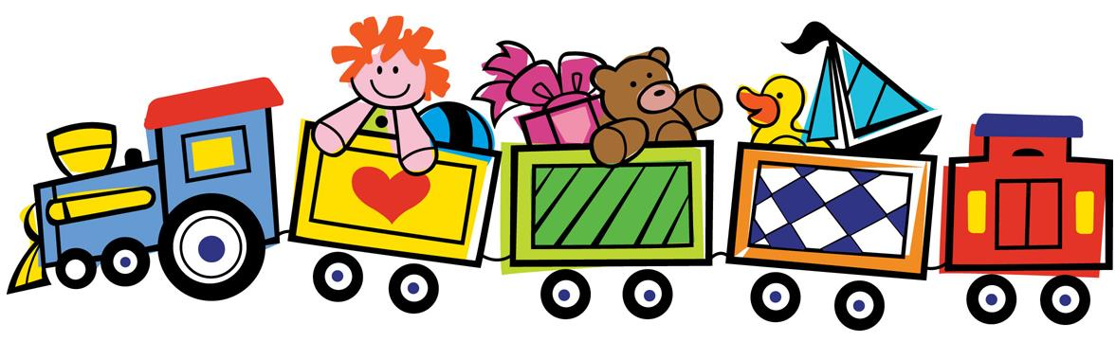

**Toy Drive**

**Benefitting**

**Local Children’s**

**Hospitals**

April 1 – May 30

**Toy Delivery on June 3, 2024**

**Donations can be dropped off or delivered to:**

**New, Unopened Toys, Books, or Crafts**

Florida Donations: 1) email [traceyscorn@icloud.com](mailto:traceyscorn@icloud.com)

**Birth to**

**18 years**

2) New Hope Church, Valrico, Florida

Connecticut/Other Donations:

1. Jill Heilman 5 Sanfords Bridge

East Haddam, CT 06423

|  |  |  |
| --- | --- | --- |
|  | For more information contact us at  [jillianheilman@gmail.com](mailto:jillianheilman@gmail.com) |  |

[**www.thehallegracefoundation.org**](http://www.thehallegracefoundation.org)

**Honoring Halle’s 24th by**

**bringing JOY to children in the hospital!**