** 7th Annual**

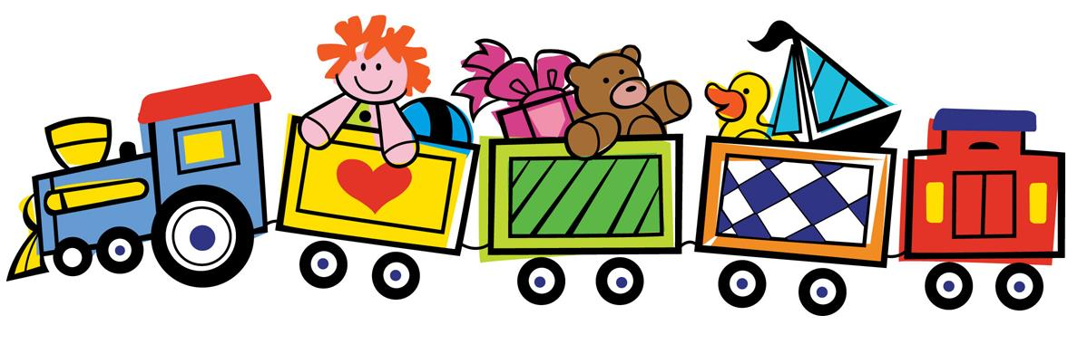

**Toy Drive**

**Benefitting**

**Local Children’s**

**Hospitals**

April 1 – May 30

**Toy Delivery on June 2, 2023**

**Donations can be dropped off or delivered to:**

The Halle Grace Foundation

|  |  |  |
| --- | --- | --- |
| **Birth to**  **18 years** | c/o Jill Heilman  2928 Chelsea Woods Dr.  Valrico, FL 33596  or contact us at  [jillianheilman@gmail.com](mailto:jillianheilman@gmail.com) | **New, Unopened Toys, Books, or Crafts** |

[**www.thehallegracefoundation.org**](http://www.thehallegracefoundation.org)

**Honoring Halle’s 23rd by**

**bringing JOY to children in the hospital!**